Lean Transform / Operational Excellence
Assignment Guidelines for the External Service Provider
A
LeanTransform is a large scale, extensive and holistic training programme which focusses on developing the capability and capacity of employees.
The objective is to support an Organisational Innovation programme focussed on;
- Improving the on-going flow of value to customers,
- Implementation of team based problem solving and continuous improvement & innovation activities,
- Continuous and shared learning,
- The identification and removal of wasteful activities in the business and supply chain,
- Leadership and management development to enable the alignment of operations to company strategy.
The aim of the Operational Excellence offer is to support established companies to address their competitive challenges and growth opportunities through a transformation project that would include investment in:
- Business Innovation: the implementation of new and innovative production, delivery or organisational methods
- Capital equipment
- Capability building through training
Lean Transform and Operational Excellence projects should deliver company-wide transformation in culture and productivity performance. In order to build sustainable businesses that can grow into the future, a LeanTransform/Operational Excellence project is about investing in people and should lead to higher quality jobs as well as a productivity improvements.
Projects should also consider the environmental sustainability of the business and include training where appropriate to increase the agility and resilience of the company to environmental climate change impacts.
Projects may vary in size and scope but will typically be 12-24 months in duration.

Lean Transform /Operational Excellence Training Specifications
Lean Transform Training Specifications are required for each individual training programme.
- Lean Transform Training Specifications should include:
Title, Objective(s), Duration, Programme content/Modules covered

- A Training Specification example is given on Page 4.

Lean Transform / Operational Excellence Records
Lean Transform Training Records are required for each individual training programme.
- Lean Transform Records should include:
Title of Training, Date, Duration, Trainee signature, Trainer signature

- All training records must be dated and signed by trainer and trainee.

- A Training Record template and a Training Record example are given on pages 5 and 6.

Lean Transform / Operational Excellence Claim
- Lean Transform Training Specifications and Training Records are required for each individual training programme.

- No Training Programme Specifications &/ No Training Records (signed and dated) will result in DISALLOWED FUNDING.

- Lean Transform metrics are required prior to each claim. A metrics table is given on page 7.

- A Lean Transform case study is required prior to the final claim. A case study template is given on page 8. Companies are asked for permission to upload the case study to the Enterprise Ireland and Lean Business Ireland Website (note that this is optional).

To be completed by the Company Contact Person

Company Name: Date:
Company Contact:

Enterprise Ireland is committed to its transparency obligations under the General Data Protection Regulation (GDPR). Our data protection notice for personal data that is supplied to us by our clients is available here. This notice contains important information about how we process personal data that is supplied to us by clients. We request that you read the notice carefully and that you ensure that it is made available to any data subjects (e.g. your employees) whose personal data you provide to us.

By ticking I agree, you confirm that: (a) you have complied with your own data protection obligations in respect of the personal data that you supply to us and that you are entitled to disclose such personal data to us; and (b) you will ensure that a copy of our data protection notice (available here) is sent to data subjects (e.g. your employees) whose personal data you provide to us.

I agree

Training Specification Example

Leadership

This programme is designed is to develop the management skills of participants.
Course Objectives
Leading People and Teams programme aims to develop the capability and confidence of managers, supervisors and team leaders in the basic skills required to manage effectively. It provides a structure and supportive framework for increasing self-awareness, building and maintaining positive workplace relationships, identifying everyday challenges and developing strategies and techniques for managing effectively.
The key objective on Leading People and Teams is to develop the management skills of participants. This programme offers the skills for career advancement along with those necessary to manage people.
Course Duration
- 3 days

Course Content
- Introduction to Management
- Managing Self
- Management Styles
- Management Responsibilities
- Building and Leading Effective Teams
- Decision-Making in Management
- Coaching to Improve Performance
- Performance Management
- Delegation
- Managing Effective Meetings

Course Pre-requisites
None

Training Record Template
TRAINING RECORD

Trainer Name:
Training Programme:
(As per specification)
Date & Location:
Duration (days):

Trainee Name (Printed/BLOCK CAPITALS) | Trainee Signature

Trainer Signature: Date: _______________
Training Record Example
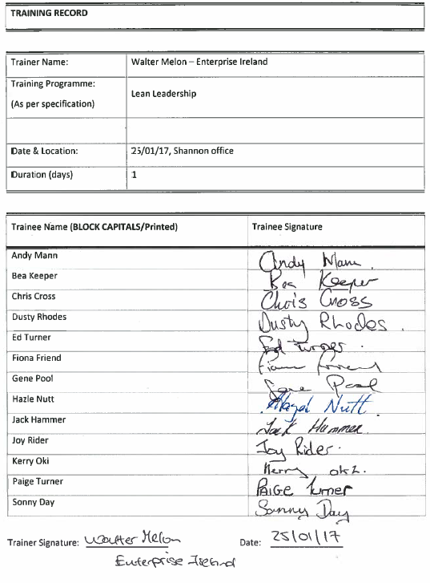

Lean Transform / Operational Excellence Metrics (Macro & Micro) Outcomes
Please provide cost savings achieved in areas such as:
- Labour
- Unit
- Utility
- Materials
- Resources (e.g. energy/water/waste)
Have the company achieved any other savings?
Please give examples of specific projects
Have the company achieved improvement in the following? (Please give details)
- Productivity
- Yield
- Output
- Capacity
Have the company recorded any improvements in the following? (Please give details)
- Sales
- Employment
- Profitability
Please state any Qualitative Improvements,
e.g. Improved Communication, environmental awareness

Please provide information on any other Impacts
This information helps us to justify the States continuing investment in Lean.
Lean Transform / Operational Excellence Case Study Template
Company Name
Address
Website
What we do
Who we are
LEAN Project Objectives
Key Challenges
Key Changes
Results/Outcomes
Quote
Lean Service Provider
Link to Lean case studies on the Enterprise Ireland website: https://www.enterprise-ireland.com/en/Productivity/Lean-Business-Offer/Lean-Case-Studies/

